BEAM BASED ALIGMNMENT AT SPEAR

Gregory J. Portmann and the Spear3 Commissioning Team
February 2005

Contents
- Introduction
- Preliminary Checks
- Initial Offsets at Spear
- Offset Measurements from February 2004 to July 2004
- Offset Measurements in October 2004 (After the Summer Shutdown)
- Offset Measurements in January 2005 (After the Fall 2004 Shutdown)
- Repeatability and Current Dependence Measurements
- Procedure for BPM Offset Measurements

Introduction
In a storage ring it is beneficial to have the beam orbit pass as close as possible to the center of the quadrupole magnets for a variety of reasons. First, if the beam orbit passes through the magnetic center, there is no steering of the orbit from the quadrupole which means that the quadrupole does not generate any orbit distortion or spurious dispersion. Second, if there is some quadrupole power supply jitter, then the amount of the orbit motion caused by the power supply jitter will be minimized. Third, if there are some higher order magnetic multipole components in the quadrupole, then the effect of higher order multipole feeddown will be minimized resulting in a smaller impact on the beam dynamics. Many storage rings have implemented a method of finding the positional offset between the electrical center of the beam position monitors (BPM) and the magnetic center of the adjacent quadrupole magnets. The algorithm for accomplishing this is usually based on modulating the current in the quadrupole magnet and finding the beam position that minimizes the orbit perturbation. The algorithm use in this paper was originally coded in Matlab at the ALS and ported to Spear with almost no changes.

Preliminary Checks
Fig. 1 shows the quadrupole center measurement for quadrupole QFC(2,1) with neighboring BPM(2,4).
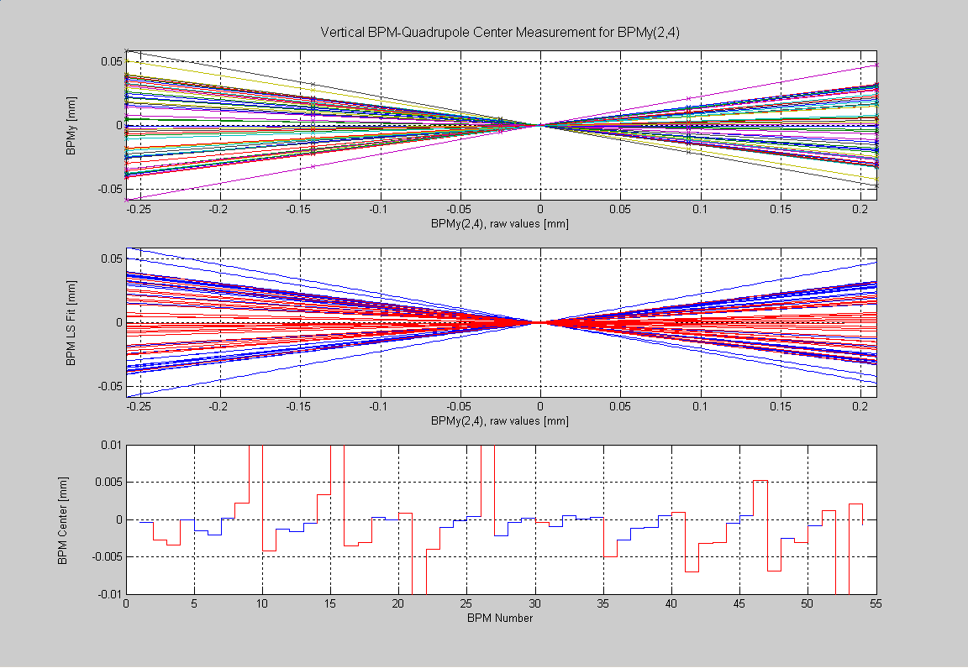
Fig. 1. Quadrupole Center of BPMy(2,4), QFC(2,1)

Fig. 2 shows the effect of modulation current amplitude on the calculation of the magnet center. Ideally this effect would be zero, however, there does appear to be a small systematic effect. Increasing the current should reduce the effect of orbit noise on the measurement but it also may increase a nonlinear beam dynamics effect. Increasing the modulation current allows one to decrease the corrector currents so the net affect on nonlinearities is not so clear. Since the errors are small the best solution to parameter selection was not fully explored. The default parameters stored in quadcenterinit are the following.

Modulation Current = 10 Amps
Corrector Magnet Change = ±.2 HCM, ±.75 VCM Amps

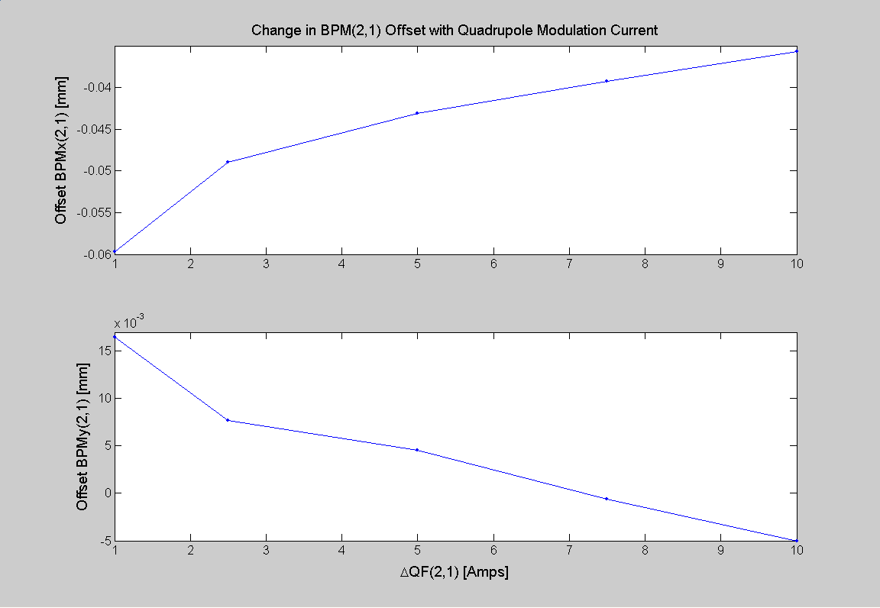
Fig. 2. Offset Change vs Modulation Current

Initial Offsets at Spear
Experimenting with measuring BPM offsets in the new Spear ring started in December 2003 and the first set of measured offsets that were trusted was on February 2, 2004 (directory 2004-02-02_07-20-34). Fig. 3 shows the starting BPM offsets. These offsets were loaded into the BPM EPICS IOC crates so that the starting reference (offset) orbit is zero. The offsets are periodically re-measured (data shown in the next section) but the IOC offsets are only updated for a drastic reason, like a ring realignment or a BPM has been repaired.

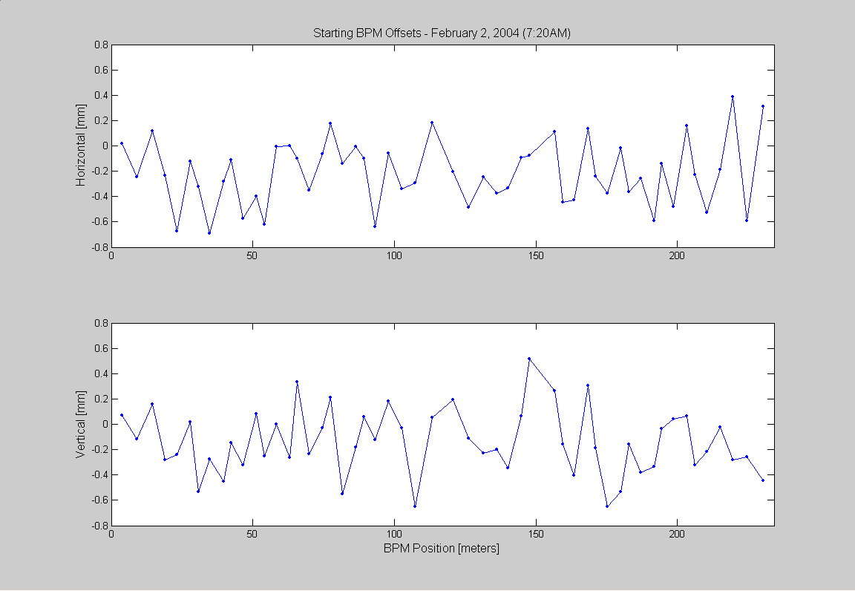
Fig. 3. Starting BPM Offsets

Offset Measurements from February 2004 to July 2004
Back-to-Back Offset Measurements
Fig. 4. shows two back-to-back offset measurements—approximately 3.5 hours apart (data directories 2004-03-11_04-10-10 and 2004-03-11_07-36-43). The RMS and maximum variation between the measurements is reasonably small.

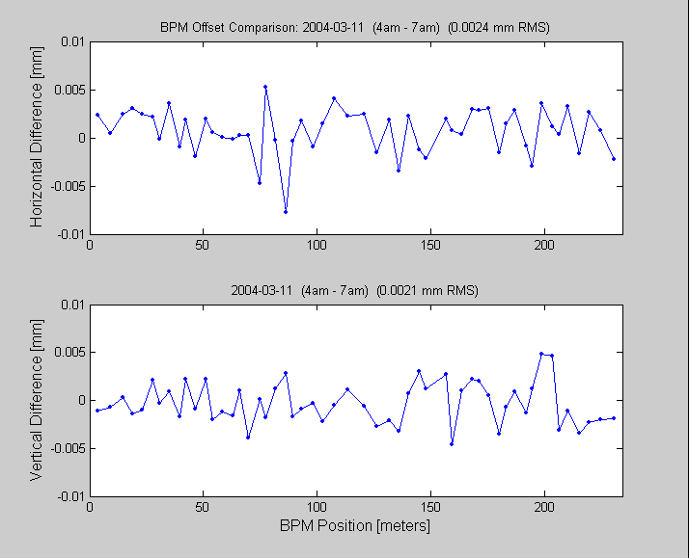 Fig. 4. Two back-to-back offset measurements (at 100 mAmps).

Beam Current Dependence
Fig. 5 shows the effects of beam current on the offset (data directories 2004-03-11_22-53-54 and 2004-03-12_01-49-44). As shown in Fig. 4, some of the “current dependence” can be blamed on measurement repeatability.
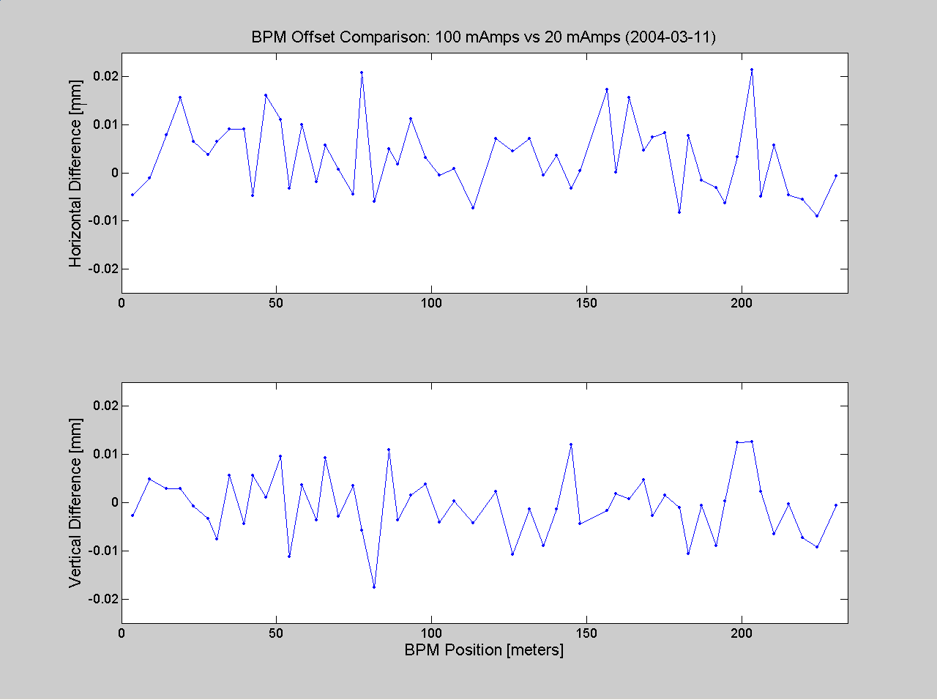
Fig. 5. BPM Offset Difference: 20 vs 100 mAmps

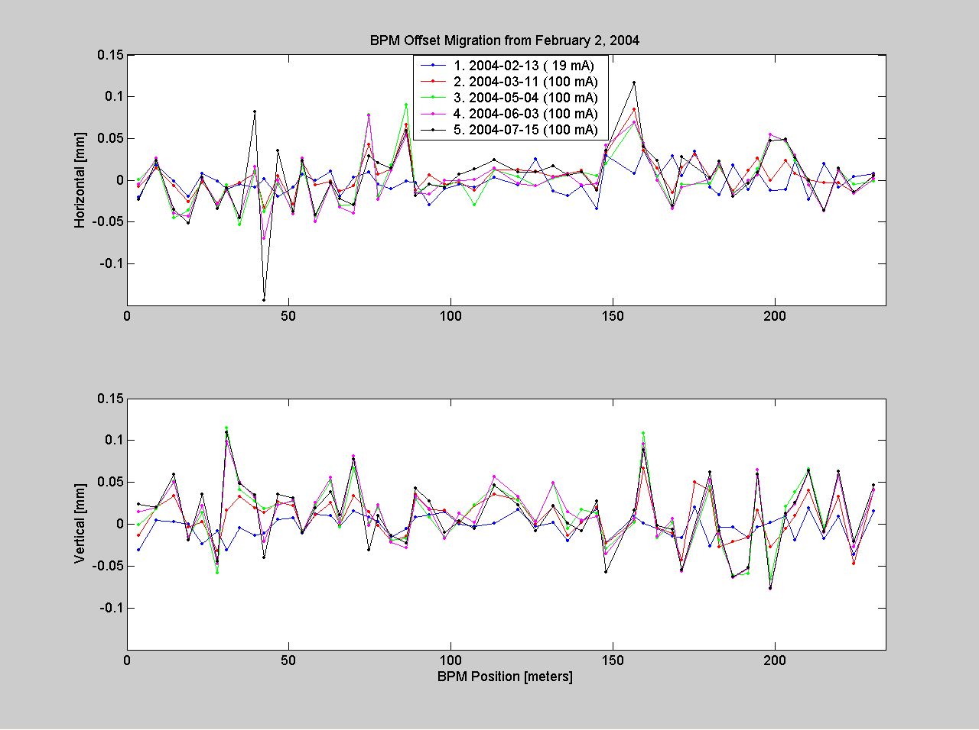
Fig. 6. BPM Offset Drift
Long Term Drift
Long term drift of the offsets is important to track. It’s difficult to know all the causes of the drift. It is assumed that most of the drift is caused by mechanical motion of the quadrupoles and BPM vacuum chambers. However, BPM electronics and cabling can also contribute to the drift. Fig. 6 shows the drift in the BPM offsets from February 2, 2004 to July 15, 2004. The x-axis is the February 2, 2004 measurement. The magnitude of the offset drift over this 5 month period is larger than one would like, however, given the variation in ambient air temperature over this period it does not seem unreasonable. The “short term” orbit stability requirement for most light sources is only a few microns, but the long term stability requirement is vaguer. Some thought and discussion with the user community should put into determining reasonable long term stability specifications.

Offset Measurements in October 2004

(After the Summer Shutdown)
During the August and September shutdown of 2004 one third of the storage ring was realigned and couplers were installed on many of the BPMs. Theoretically the coupler installation should not affect the BPM reading, however, BPMs are notoriously sensitive to any changes in cabling or electronics. Simply disconnecting and reconnecting a BPM cable has been known to produce beam position changes of tens of microns. Fig. 7 shows change in BPM offsets over the August and September shutdown. The BPMs where couplers have been installed have an “x” marker. Although most of the large offset differences have couplers there are a number of BPM showing large offsets without cabling changes. However, keeping track of every change made to the BPM systems was not done for this report.

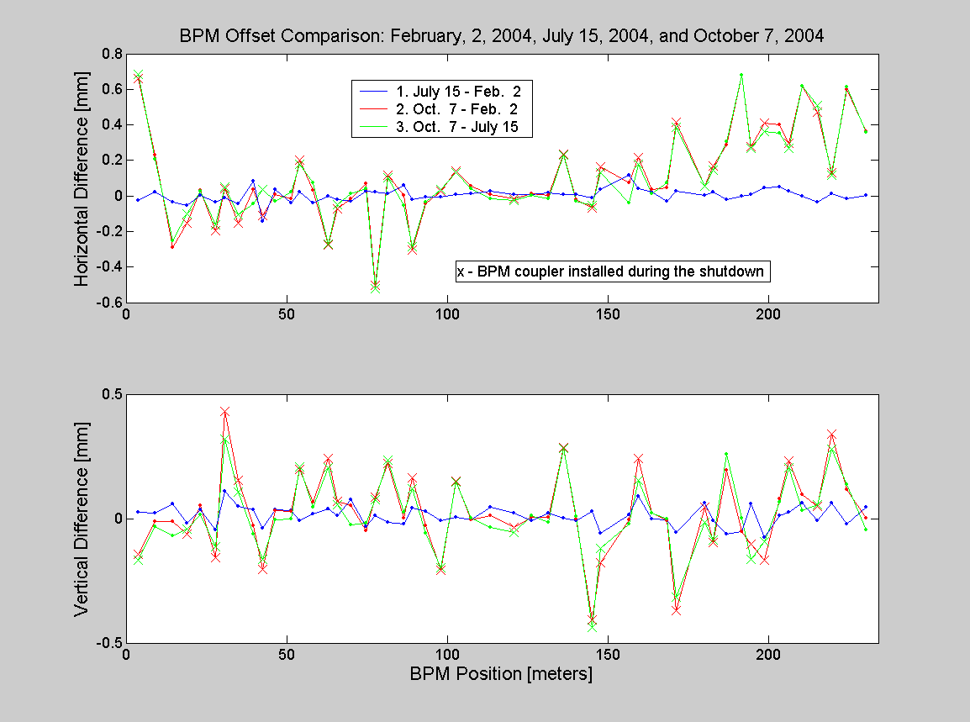Fig. 7. BPM Offset Change after a 2 Month Shutdown.
Data for Offset Measurement on October 7, 2004

Position X-Offset Y-Offset

[meters] [mm] [mm]

BPM( 1,1) 3.7 0.6594 -0.1435 Coupler Installed

BPM( 1,4) 9.1 0.2322 -0.0127

BPM( 1,7) 14.5 -0.2894 -0.0115

BPM( 2,1) 19.0 -0.1513 -0.0625 Coupler Installed

BPM( 2,4) 23.1 0.0301 0.0507

BPM( 2,6) 27.9 -0.1971 -0.1586 Coupler Installed

BPM( 3,1) 30.7 0.0426 0.4294 Coupler Installed

BPM( 3,4) 34.8 -0.1529 0.1554 Coupler Installed

BPM( 3,6) 39.6 0.0353 -0.0279

BPM( 4,1) 42.4 -0.1090 -0.2043 Coupler Installed

BPM( 4,4) 46.5 0.0054 0.0316

BPM( 4,6) 51.3 -0.0172 0.0275

BPM( 5,1) 54.1 0.2021 0.1991 Coupler Installed

BPM( 5,4) 58.2 0.0332 0.0656

BPM( 5,6) 63.0 -0.2746 0.2429 Coupler Installed

BPM( 6,1) 65.8 -0.0733 0.0677 Coupler Installed

BPM( 6,4) 69.9 -0.0179 0.0529

BPM( 6,6) 74.7 0.0683 -0.0484

BPM( 7,1) 77.5 -0.5013 0.0847 Coupler Installed

BPM( 7,4) 81.6 0.1143 0.2205 Coupler Installed

BPM( 7,6) 86.4 0.0043 0.0015

BPM( 8,1) 89.2 -0.3062 0.1628 Coupler Installed

BPM( 8,4) 93.3 -0.0423 -0.0301

BPM( 8,6) 98.1 0.0269 -0.2090 Coupler Installed

BPM( 9,1) 102.6 0.1398 0.1511 Coupler Installed

BPM( 9,4) 107.4 0.0538 -0.0048

BPM( 9,7) 113.3 0.0077 0.0117

BPM(10,1) 120.8 -0.0152 -0.0342 Coupler Installed

BPM(10,4) 126.1 0.0134 0.0034

BPM(10,7) 131.5 0.0014 0.0055

BPM(11,1) 136.1 0.2346 0.2845 Coupler Installed

BPM(11,4) 140.2 -0.0190 -0.0006

BPM(11,6) 145.0 -0.0669 -0.4085 Coupler Installed

BPM(12,1) 147.8 0.1644 -0.1779 Coupler Installed

BPM(12,6) 156.7 0.0761 -0.0047

BPM(13,1) 159.5 0.2160 0.2422 Coupler Installed

BPM(13,4) 163.6 0.0358 0.0213

BPM(13,6) 168.4 0.0457 -0.0098

BPM(14,1) 171.2 0.4152 -0.3716 Coupler Installed

BPM(14,6) 180.0 0.0563 0.0462 Coupler Installed

BPM(15,1) 182.9 0.1689 -0.0952 Coupler Installed

BPM(15,4) 187.0 0.2885 0.1958

BPM(15,6) 191.7 0.6775 -0.0512

BPM(16,1) 194.6 0.2784 -0.1038 Coupler Installed

BPM(16,4) 198.7 0.4090 -0.1682 Coupler Installed

BPM(16,6) 203.4 0.4010 0.0778

BPM(17,1) 206.2 0.2968 0.2319 Coupler Installed

BPM(17,4) 210.4 0.6170 0.0952

BPM(17,6) 215.1 0.4725 0.0477 Coupler Installed

BPM(18,1) 219.7 0.1300 0.3410 Coupler Installed

BPM(18,4) 224.4 0.5966 0.1169

BPM(18,7) 230.4 0.3620 0.0017

Offset Measurements in January 2005

(After the Fall/Winter 2004 Shutdown)
A full quadrupole centering measurement was done during the January 2005 startup after being down for several months. The data is shown in Fig. 8 below. The difference orbits are quite large however changes to the BPMs systems could have been made over the shutdown. As mentioned before, simply disconnecting and reconnecting a BPM cable has been known to cause a center shift on the order of tens of microns.

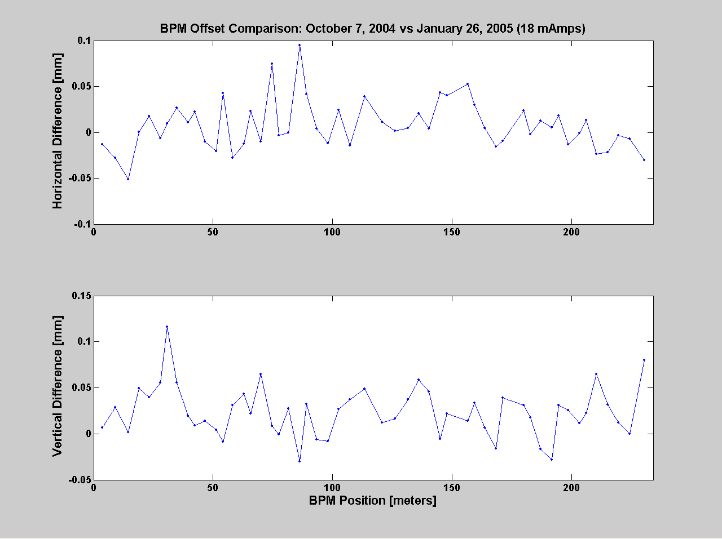
Fig. 8. BPM Offset Change after Fall/Winter 2004 Shutdown.

Repeatability and Current Dependence Measurements
To get a feeling for the repeatability of the quadrupole center measurement the quadrupoles in sector 9 were measured many times. The goal was to measure the repeatability without changing anything on the machine (back-to-back measurements) and also check the repeatability at different currents. The thought was that if the back-to-back measurement repeatability was very good, then the quadrupole center measurement could be a good measure of current dependence of the BPMs. The results are shown below in Fig. 9-11. The top plots show the center measurement as a function of beam current and the bottom plots show the center measurement as a function of measurement date. Notice that the measurements were done in two groups about 2 days apart. The measurement order with current was 18mA, 75mA, 60mA, 100mA, 90mA, 45mA, 85mA, 25mA, 55mA filling 280 bunches. The sequence was done twice, however, due to measurement glitches a few of the data point have been discarded. The repeatability of the measurement varies between ±3 µm to ±10µm depending on the particular BPM and plane. Some of the variation could be due to vacuum chamber motion or other systematic effects – the vertical BPMs on January 28 show a linear slope with time. The variation with beam current is below the back-to-back measurement repeatability. Overall, the repeatability of the measurement is very good and quite acceptable for Spear operations.
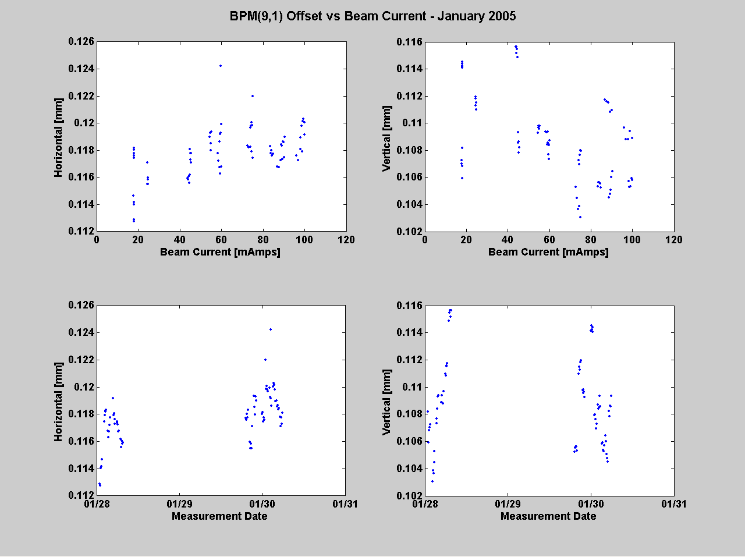 Fig.9. BPM(9,1) Repeatability and Current Dependence.

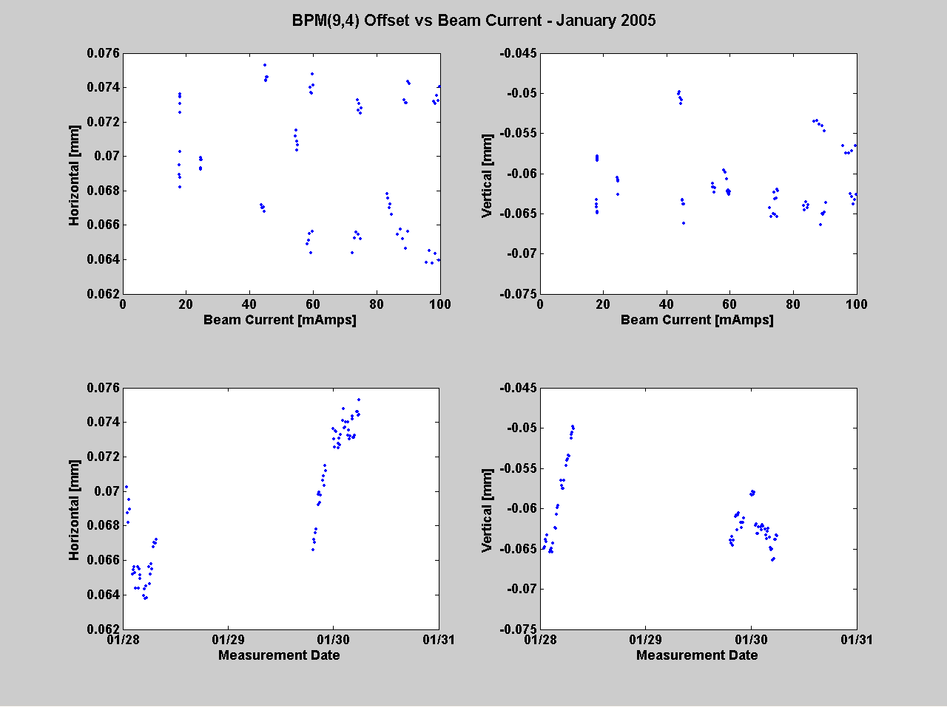
Fig. 10. BPM(9,4) Repeatability and Current Dependence.

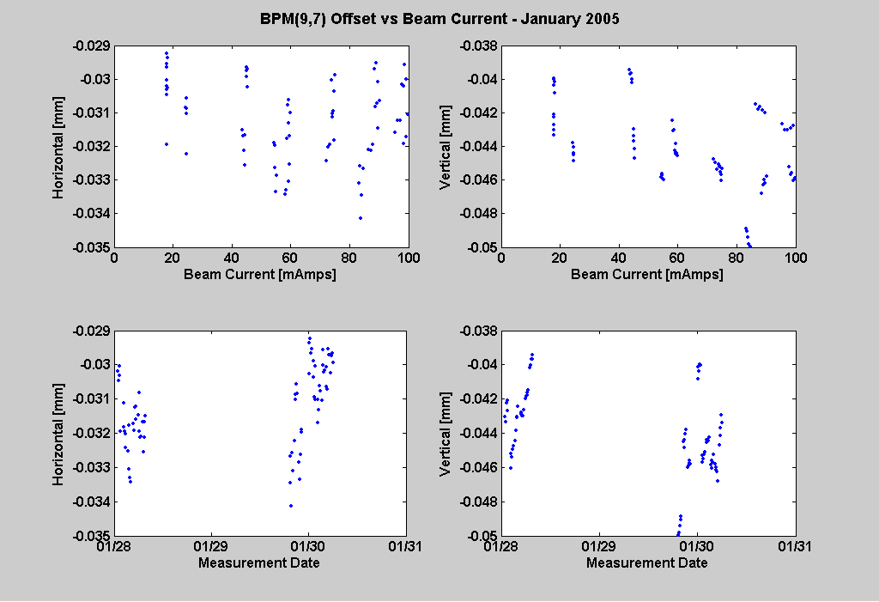 Fig. 11. BPM(9,7) Repeatability and Current Dependence.

A Comment on Errors
Identifying all the error sources with this measurement is very difficult. This will be the topic of another report. Potential errors that come to mind are the following.
- Orbit and BPM Noise – at Spear the total orbit and BPM noise is about .2µm rms. This should contribute very little error to the QMS measurement. For example, simulation results for QDX(9,1) with the only error source being a .2µm rms orbit motion produced a center calculation accurate to .05µm. However, this assumes Gaussian errors. Orbit jumps or glitches could be problematic.
- BPM nonlinearities – “pin-cushion” effects
- Quadrupole magnet power supply errors
- Corrector magnet power supply errors
- Phase advance between the BPM and the quadrupole. This error could be relatively “large.” For example, putting 1 mm random orbit distortion in the simulator and measuring the center of QDX(9,1) caused a 10µm error.
- Any optics effects which cause nonlinearity of the merit function will be problematic.

Procedure for BPM Offset Measurements at Spear

quadcenter finds the center of the QF and QD magnets and records the position of the neighboring BPM.
quadcenterall finds the center of all the BPMs located next to quadrupoles with backleg windings.

Procedure:
- Start Matlab (may need to run spear3init)

- The magnet lattice should be setup almost as it is for normal user operations.
- run srinit
- Standardize the storage ring magnets.
- Multi-bunch mode.
- Fill to 100 mAmps. Lower beam current is also fine since the current dependence of the BPMs is small. Make sure that the fill pattern is relatively even. Also, beam based alignment works fine with the orbit interlock system.
- Load the proper production (user) magnet lattice.
- Make sure that all corrector magnets and BPMs are working properly.
- Correct the orbit to the offset orbit.

- Run quadcenterall

To find the center of one magnet at a time, run quadcenter
- Select a sector from the menu.
- Select the desired quadrupole in that sector from the menu.

- The quadrupole center programs will plot the results to the screen. Use quadplot to re-plot a particular data file. Fig. 1 shows an example plot. The top plot in Fig. 1 shows the raw data for all BPMs. The bow tie shape clearly shows the center of the quadrupole relative to the BPM. If the bowtie plot does not look reasonable close to this, then redo the magnet. If the center for the bowtie is shifted off the plot, then another iteration (find/update offset, corrector orbit, find offset again) for that magnet is required. The second plot shows the least squares fit to the data. The third plot shows the least squares fit to the data when the outliers and lines with small slopes have been removed. The bottom plot shows the computed quadrupole center for each BPM. The reported center is the average of all the individual BPM calculated centers after the outliers and lines with small slopes have been removed. The quadrupole center data is automatically saved to a subdirectory of the QMS directory named by date and time of day.

- Use quadplotall to plot the results for the entire measurement. For this program to work all the data must be located in one directory. If a magnet is measured twice then make sure only one of the files is in the directory. The BPM offsets determined from quadcenterall must manually be added to the PhysData file (setphysdata) – step #6. Compare the plots with past data as a sanity check on the measurement.

[x, y] = quadplotall('r:\controls\matlab\spear3data\User\QMS\<MeasurementDirectory>');

- The offset orbit determined by the quadrupole center and the golden orbit is offset orbit plus a bump in two BPMs (the injection straight section). The following will commands will set the new offset and global orbits in the Matlab Middlelayer.

setphysdata('BPMx', 'Offset', x(:,3), x(:,1:2));
setphysdata('BPMy', 'Offset', y(:,3), y(:,1:2));
n36 = findrowindex([3 6], x(:,1:2));
n41 = findrowindex([4 1], x(:,1:2));
x(n36, 3) = x(n36, 3) - .26;
x(n41, 3) = x(n41, 3) + .26;
setphysdata('BPMx', 'Golden', x(:,3), x(:,1:2));
setphysdata('BPMy', 'Golden', y(:,3), y(:,1:2));

Note 1: spear3init (or setoperationalmode) needs to be run after changing spear3physdata.
Note 2: If quadrupole centering is being run after a BPM repair/replacement, then the offset should probably go in the EPICS hardware offset data record for that BPM – not the Middlelayer. When doing this it is better to set the EPICS hardware BPM gain to unity before running the QMS algorithm. That way the offset can be directly summed with the EPICS record offset with scaling. In general, be careful when changing the .ESLO or .EOFF EPICS fields. It’s easy to make a mistake. Contact the orbit czar before changing the EPICS fields. Gain adjustments will need to be done with LOCO.

